CLINIC MANAGEMENT SYSTEM
A PROJECT REPORT

Submitted by

ANJALI KUMARI (23BCA10790)

in partial fulfillment for the award of the degree of

BACHELOR OF COMPUTER APPLICATIONS
IN
COMPUTER SCIENCE AND ENGINEERING


Chandigarh University
April 2026

CERTIFICATE

This is to certify that the Minor Project entitled "Clinic Management System" has been successfully completed by Anjali Kumari, Roll No. 23BCA10790, a student of B.C.A., University Institute of Computing (UIC), 6th Semester, at Chandigarh University during the academic year 2023–2026.

The project has been carried out under our guidance and supervision. To the best of our knowledge and belief, the work embodied in this report is original and has not been submitted to any other institution or university for the award of any degree or diploma.

The project is an Excel-based Clinic Management System that covers patient record management, automated billing, daily attendance tracking, and a real-time summary dashboard. It fulfills all the requirements as per the norms prescribed by the institution for the partial fulfillment of the Minor Project submission.

Project Guide  Mrs. Rashmi maam  UIC  Chandigarh University | Head of Department  Prof./Dr. Arun  UIC  Chandigarh University

ACKNOWLEDGEMENT

I would like to express my sincere gratitude and appreciation to all those who contributed to the successful completion of this minor project on "Clinic Management System."

First and foremost, I am deeply grateful to my Project Guide, Prof.Rashmi maam, for their invaluable guidance, constructive suggestions, and continuous encouragement throughout the duration of this project. Their expertise and insights were instrumental in shaping this work.

I extend my heartfelt thanks to Prof./Dr. Arun, Head of the Department of University Institute of Computing, for providing the necessary resources and support to carry out this project.

I am also grateful to the teaching faculty of the Department of University Institute of Computing for their academic support and motivation throughout the semester.
Finally, I express my deepest gratitude to my family for their unwavering support, encouragement, and patience during the course of this project.

Anjali Kumari
Roll No: 23BCA10790
University Institute of Computing
Chandigarh University

ABSTRACT

The Clinic Management System is a spreadsheet-based application developed entirely using Microsoft Excel, designed to digitize and automate the routine operations of a small clinic or hospital. The system eliminates the need for manual record-keeping by providing a structured, formula-driven digital solution that is lightweight, portable, and usable without any programming knowledge or specialized software.

The project is organized across four dedicated Excel worksheets:
(1) Patient Records — stores complete information for 25 patients including name, age, assigned doctor, visit fee, number of visits, total bill, cost status (HIGH COST / NORMAL), fee type (EXPENSIVE / AFFORDABLE), follow-up flag, and attendance percentage.
(2) Visit Tracker — records daily attendance (P/A) for each patient across a 5-day working week (Monday to Friday) and auto-calculates total visits and attendance percentage.
(3) Dashboard — provides a real-time summary including total patients, revenue, average billing, doctor-wise breakdown, and cost distribution.
(4) Formulas Used — a reference sheet documenting all Excel formulas used in the project.

The system leverages twelve Excel formulas including SUM, AVERAGE, IF, COUNTIF, COUNTA, VLOOKUP, AVERAGEIF, SUMIF, and IFERROR to ensure all calculations are fully dynamic and auto-updating. Key results from the system: Total Revenue = Rs. 1,20,420 across 93 visits by 25 patients; Average Bill = Rs. 4,816.80; 10 patients classified as HIGH COST and 15 as NORMAL; Dr. Rajesh Kumar recorded the highest average bill (Rs. 6,608.33).

The system was validated through 10 functional test cases covering billing calculations, cost classification, attendance tracking, VLOOKUP linking, and dashboard aggregation — all of which passed successfully. This project demonstrates practical proficiency in spreadsheet design, formula-based automation, and data-driven system development, and provides a strong foundation for future enhancement with database integration, graphical analytics, and web-based deployment.

TABLE OF CONTENTS

CERTIFICATE ................................................................................................................ 2
ACKNOWLEDGEMENT ..................................................................................................3
ABSTRACT .....................................................................................................................4
CHAPTER 1. INTRODUCTION ...................................................................................... 6
Need for the System ....................................................................................................... 6
Problem Statement ......................................................................................................... 6
Basic Idea of the Solution ............................................................................................... 7
Organization of the Report ...............................................................................................7
CHAPTER 2. PROJECT OVERVIEW ..............................................................................8
2.1 What We Made ..........................................................................................................8
2.2 Features of the System ............................................................................................. 8
2.3 Sheets in the Workbook ............................................................................................ 9
2.4 Tools Used ................................................................................................................ 9
CHAPTER 3. DESIGN FLOW / IDEA ............................................................................ 10
3.1 Planning the System ............................................................................................... 10
3.2 Design Flow ............................................................................................................. 11
3.3 Why We Used Formulas Instead of Manual Values ................................................ 11
CHAPTER 4. RESULTS ANALYSIS AND VALIDATION ............................................... 13
4.1 Patient Records — Full Data .................................................................................... 13
4.2 Visit Tracker Output ................................................................................................. 14
4.3 Dashboard Summary ............................................................................................... 14
4.4 Formulas Used ......................................................................................................... 15
4.5 Test Cases and Validation ....................................................................................... 15
CHAPTER 5. CONCLUSION AND FUTURE WORK .................................................... 16
5.1 Conclusion ................................................................................................................16

CHAPTER 1. INTRODUCTION

1.1 Need for the System
In a busy clinic or small hospital, managing patient records, billing, and daily attendance manually is an extremely challenging and error-prone task. Doctors and clinic staff are required to maintain physical registers, calculate bills by hand using calculators, and track each patient visit individually. This process is not only time-consuming but is also susceptible to errors, data loss, and inconsistency.

In the current project scenario, a clinic handles 25 patients across four doctors — Dr. Anil Gupta, Dr. Sunita Mehta, Dr. Rajesh Kumar, and Dr. Priya Sharma — with visit fees ranging from Rs. 600 to Rs. 1,950. Tracking these manually over a working week and generating billing summaries would require significant manual effort. There is a clear need for a simple, organized, and easy-to-use system that consolidates all clinic-related work in one place and automates calculations.

1.2 Problem Statement
The following specific problems were identified in the manual clinic management process that motivated the development of this system:
- Patient records are stored in physical registers which can get lost or damaged, with no backup mechanism.
- Billing calculations (Visit Fee × Number of Visits) are done manually, leading to frequent arithmetic errors and inconsistencies.
- There is no centralized way to determine how many patients visited on any given day of the week.
- Calculating each patient's attendance percentage over a week requires manual counting and division, which is tedious.
- Identifying HIGH COST vs NORMAL patients or EXPENSIVE vs AFFORDABLE fee types requires manual comparison.
- Doctor-wise performance summaries such as average billing per doctor cannot be generated quickly without a system.
- There is no summary dashboard to get an overall picture of clinic operations at a glance.

1.3 Basic Idea of the Solution
The proposed solution is to create a Clinic Management System using Microsoft Excel. Excel is a widely available, easy-to-use tool that requires no special installation or programming knowledge, making it ideal for a clinic with basic computing infrastructure. By designing multiple interconnected worksheets and applying Excel formulas, we can automate all the tasks currently done manually.

The system comprises four Excel sheets: Patient Records (core data with automated billing and classification), Visit Tracker (daily attendance with auto-calculated totals), Dashboard (real-time summary statistics and doctor-wise breakdown), and Formulas Used (documentation of all formulas). Together, these sheets form a complete, dynamic, and self-updating Clinic Management System.

1.4 Organization of the Report
This report is organized into five chapters. Chapter 1 introduces the problem, the need for the system, and the proposed solution. Chapter 2 provides a detailed overview of what was built, including the sheet structure and all features. Chapter 3 describes the design thinking, planning process, and technical design decisions. Chapter 4 presents actual results with real data from the system and validates all formulas through test cases. Chapter 5 provides the conclusion and outlines a roadmap for future improvements.

CHAPTER 2. PROJECT OVERVIEW
This chapter provides a detailed description of the Clinic Management System built as part of this project, covering all modules, features, and tools used.

2.1 What We Made
We developed a fully functional Clinic Management System using Microsoft Excel 2016+. The system manages records of 25 patients across 4 doctors, automates all billing and attendance calculations using Excel formulas, and provides a real-time summary dashboard. The entire workbook is formula-driven — changing any input value (such as a visit fee or attendance mark) automatically updates all related calculations across all sheets.

The system covers three major functions of clinic management: (1) Patient Administration — recording patient demographics and doctor assignments; (2) Financial Management — calculating bills, classifying costs, and generating revenue summaries; and (3) Attendance Management — tracking daily patient visits and calculating weekly attendance percentages.

2.2 Features of the System
The following are the key features of the Clinic Management System, each implemented through dedicated Excel sheets and formulas:

Feature | Description
Patient Records | Stores complete details for 25 patients: SR. No., Patient Name, Age, Doctor Name, Visit Fee (Rs.), Number of Visits, Total Bill (Rs.), Average Bill (Rs.), Cost Status (HIGH COST/NORMAL), Follow-Up (YES/NO), Fee Type (EXPENSIVE/AFFORDABLE), and Attendance Percentage.
Automated Billing | Total Bill is auto-calculated using =E*F (Visit Fee × Visits). Grand Total = Rs. 1,20,420 and Average Bill = Rs. 4,816.80 are calculated using SUM and AVERAGE formulas.
Cost Classification | Patients are automatically classified as HIGH COST (Total Bill > Rs. 5,000) or NORMAL using the IF formula. 10 patients fall in HIGH COST and 15 in NORMAL category.
Fee Type Classification | Visit fees are classified as EXPENSIVE (>= Rs. 1,000) or AFFORDABLE (< Rs. 1,000) using an IF formula on the visit fee column.
Visit Tracker | Records daily attendance (P = Present, A = Absent) for all 25 patients across a 5-day working week (Monday to Friday). Total visits and attendance percentage are auto-calculated using COUNTIF.
Dashboard | Provides a real-time clinic summary: Total Patients (25), High/Normal Cost split, Total Revenue (Rs. 1,20,420), Average Bill, and a Doctor-Wise Summary table with patient count and average billing per doctor.
Formulas Reference Sheet | A dedicated documentation sheet listing all 12 Excel formulas used in the project with their exact syntax and purpose, serving as a reference guide.

2.3 Sheets in the Workbook
The Excel workbook contains the following four main sheets (plus one hidden _Data sheet used as a chart data source):
- Patient Records — the primary data entry and calculation sheet with all 25 patient records and 12 columns of auto-calculated data.
- Visit Tracker — tracks daily attendance for all patients across Monday to Friday, with color-coded P (green) and A (red) cells.
- Dashboard — a summary view displaying key clinic metrics, doctor-wise statistics, and cost distribution, with visual analytics support.
- Formulas Used — a reference documentation sheet listing all formulas with their syntax and purpose for academic reference.

2.4 Tools Used
The only tool used in this project is Microsoft Excel (version 2016 or later). No external software, programming languages, databases, or macros were required. The system uses only built-in Excel formulas and standard formatting features. This makes it fully portable and operational on any computer with MS Excel installed.

CHAPTER 3. DESIGN FLOW / IDEA
This chapter explains the ideation process, the planning methodology, and the step-by-step design decisions made during the development of the Clinic Management System.

3.1 Planning the System
Before starting the development, the following requirements were identified for the system:
- Store patient demographic details (name, age) and their assigned doctor.
- Record and auto-calculate the total consultation bill based on visit fee and number of visits.
- Automatically classify each patient as HIGH COST or NORMAL and the fee as EXPENSIVE or AFFORDABLE.
- Track daily attendance of each patient across a working week and compute attendance percentage.
- Link attendance data from the Visit Tracker sheet to the Patient Records sheet using VLOOKUP.

3.2 Design Flow
The system was designed and built following this step-by-step process:

Step | Action Taken
Step 1 | Identified and documented the problem: manual clinic work is slow, error-prone, and lacks summary capabilities.
Step 2 | Decided to use Microsoft Excel as the development tool due to its availability and formula capabilities.
Step 3 | Listed all required features and decided to organize them across four dedicated worksheets.
Step 4 | Designed the Patient Records sheet with 12 columns: SR, Name, Age, Doctor, Visit Fee, Visits, Total Bill, Avg Bill, Cost Status, Follow-Up, Fee Type, Attendance.
Step 5 | Added Excel formulas for Total Bill (=E*F), Cost Status (IF), Fee Type (IF), and Average Bill (AVERAGE).
Step 6 | Created the Visit Tracker sheet with P/A attendance cells and COUNTIF formulas for total visits and attendance %.
Step 7 | Linked Visit Tracker data to Patient Records using VLOOKUP wrapped in IFERROR for error handling.
Step 8 | Built the Dashboard sheet using COUNTA, COUNTIF, SUM, AVERAGE, AVERAGEIF, and SUMIF for all summary metrics.

3.3 Why We Used Formulas Instead of Manual Values
A core design principle of this system is that all calculated values are driven by Excel formulas rather than manually entered numbers. This ensures the system remains dynamic — any change in input automatically propagates to all dependent cells. Key examples include:
- =E4*F4 for Total Bill: ensures the bill recalculates immediately if the visit fee or number of visits changes.
- =IF(G4>5000,"HIGH COST","NORMAL") for Cost Status: automatically reclassifies a patient if their total bill changes.
- =COUNTIF(C5:G5,"P")/5 for Attendance %: recalculates if any daily attendance mark is updated in the Visit Tracker.
- =VLOOKUP(B4,'Visit Tracker'!$B$5:$I$29,8,0) in Patient Records: pulls live attendance data from another sheet.
- =AVERAGEIF(D4:D28,"DR. RAJESH KUMAR",G4:G28) on Dashboard: updates doctor averages when any patient data changes.

This formula-first approach makes the system self-updating, reduces manual errors, and ensures data consistency across all four sheets of the workbook.
SCREENSHOTS
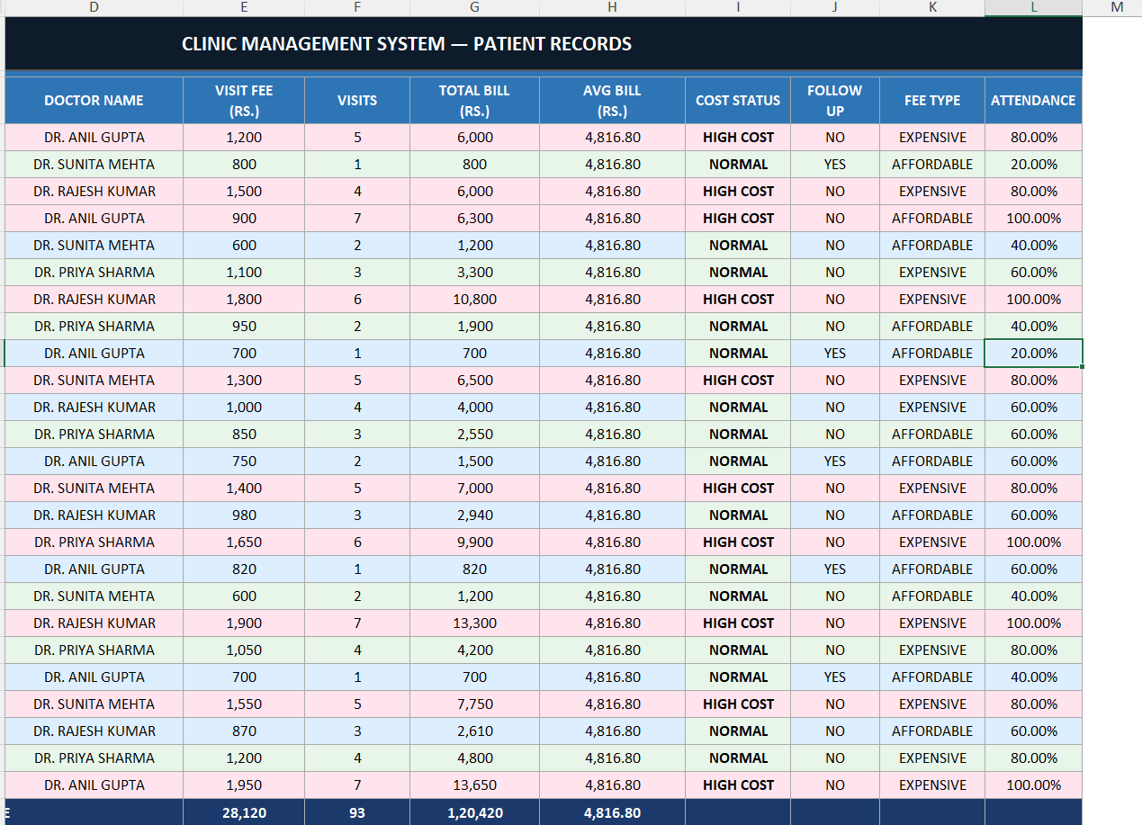

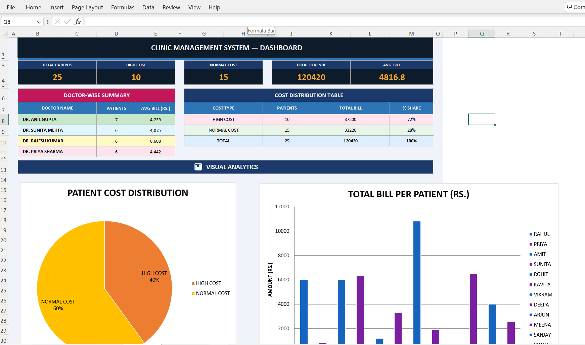

CHAPTER 4. RESULTS ANALYSIS AND VALIDATION
This chapter presents the actual output data generated by the Clinic Management System, demonstrates the working of each module with real data from the Excel workbook, and validates all formulas through structured test cases.

4.1 Patient Records — Full Data (Sample)
The Patient Records sheet stores complete information for all 25 patients. The table below shows a representative sample of 7 patient records along with their auto-calculated fields:

Patient Name | Doctor | Visit Fee | Visits | Total Bill | Cost Status
RAHUL SHARMA | DR. ANIL GUPTA | Rs. 1,200 | 5 | Rs. 6,000 | HIGH COST
PRIYA VERMA | DR. SUNITA MEHTA | Rs. 800 | 1 | Rs. 800 | NORMAL
AMIT SINGH | DR. RAJESH KUMAR | Rs. 1,500 | 4 | Rs. 6,000 | HIGH COST
SUNITA PATEL | DR. ANIL GUPTA | Rs. 900 | 7 | Rs. 6,300 | HIGH COST
ROHIT JOSHI | DR. SUNITA MEHTA | Rs. 600 | 2 | Rs. 1,200 | NORMAL
KAVITA RAO | DR. PRIYA SHARMA | Rs. 1,100 | 3 | Rs. 3,300 | NORMAL
VIKRAM MALHOTRA | DR. RAJESH KUMAR | Rs. 1,800 | 6 | Rs. 10,800 | HIGH COST
TOTAL (25 Patients) | 4 Doctors | Rs. 28,120 | 93 | Rs. 1,20,420 | 10 High / 15 Normal

All 25 patient records are stored with 12 data fields each. The total revenue across all patients is Rs. 1,20,420 from 93 total visits. The system identified 10 patients as HIGH COST (Total Bill > Rs. 5,000) and 15 as NORMAL. Visit fees range from Rs. 600 (Rohit Joshi / Aakash Verma) to Rs. 1,950 (Vikas Goyal).

4.2 Visit Tracker Output
The Visit Tracker sheet records daily attendance (P = Present, A = Absent) for all 25 patients across a 5-day working week. Total visits and attendance percentage are auto-calculated using COUNTIF formulas. A sample of 7 patient records is shown below:

Patient Name | Mon | Tue | Wed | Thu | Fri | Visits | Attend%
RAHUL SHARMA | P | P | A | P | P | 4 | 80%
PRIYA VERMA | A | A | A | A | P | 1 | 20%
AMIT SINGH | P | P | P | A | P | 4 | 80%
SUNITA PATEL | P | P | P | P | P | 5 | 100%
ROHIT JOSHI | P | A | P | A | A | 2 | 40%
KAVITA RAO | P | P | A | P | A | 3 | 60%
VIKRAM MALHOTRA | P | P | P | P | P | 5 | 100%

P cells are highlighted in green and A cells in red for quick visual identification. 8 patients achieved 100% attendance (5/5 days), while 2 patients attended only on 1 day (20% attendance). The average weekly attendance across all 25 patients is 74.4%.

4.3 Dashboard Summary
The Dashboard sheet provides a real-time clinic summary automatically calculated from the Patient Records and Visit Tracker sheets. All values update instantly when any input changes.

Metric | Value
Total Patients | 25
High Cost Patients | 10 (40%)
Normal Cost Patients | 15 (60%)
Total Revenue | Rs. 1,20,420
Average Bill per Patient | Rs. 4,816.80
Total Visits (All Patients) | 93
Male Patients | 13
Female Patients | 12

The Doctor-Wise Summary from the Dashboard shows the following:

Doctor Name | Patients | Avg Bill (Rs.) | Total Bill (Rs.)
Dr. Anil Gupta | 7 | Rs. 4,238.57 | Rs. 29,670
Dr. Sunita Mehta | 6 | Rs. 4,075.00 | Rs. 24,450
Dr. Rajesh Kumar | 6 | Rs. 6,608.33 | Rs. 39,650
Dr. Priya Sharma | 6 | Rs. 4,441.67 | Rs. 26,650

Dr. Rajesh Kumar has the highest average bill per patient (Rs. 6,608.33), driven by patients like Rekha Tiwari (Rs. 13,300) and Vikram Malhotra (Rs. 10,800). Dr. Anil Gupta has the largest patient load with 7 patients.

4.4 Formulas Used
The following table lists all 12 Excel formulas used in this project, as documented in the Formulas Used sheet of the workbook:

Formula Name | Syntax / Example | Purpose
Attendance % | =(COUNTIF(C5:G5,"P")/5) | Calculates attendance % per patient from Visit Tracker
Total Bill | =E4*F4 | Consultation fee multiplied by number of visits
Grand Total Billing | =SUM(G4:G28) | Adds all patient bills for total revenue
Average Bill | =AVERAGE(G4:G28) | Finds the average billing across all 25 patients
Avg Bill per Doctor | =AVERAGEIF(D4:D28,"DR. ANIL GUPTA",G4:G28) | Average bill for patients of a specific doctor
Cost Status | =IF(G4>5000,"HIGH COST","NORMAL") | Classifies patient as HIGH COST or NORMAL
Fee Type | =IF(E4>=1000,"EXPENSIVE","AFFORDABLE") | Classifies visit fee as expensive or affordable
Total Patients | =COUNTA(B4:B28) | Counts total number of patients in the records
High Cost Count | =COUNTIF(I4:I28,"HIGH COST") | Counts the number of HIGH COST patients
Follow-up Count | =COUNTIF(J4:J28,"YES") | Counts patients who need a follow-up visit
VLOOKUP Attendance | =VLOOKUP(B4,'Visit Tracker'!$B$5:$I$29,8,0) | Pulls attendance % from Visit Tracker sheet
IFERROR | =IFERROR(VLOOKUP(...),"") | Handles errors gracefully, shows blank on failure
Formula-to-formula linking (VLOOKUP between Patient Records and Visit Tracker, AVERAGEIF and SUMIF on the Dashboard) was verified to update correctly when source data was modified.

CHAPTER 5. CONCLUSION AND FUTURE WORK

5.1 Conclusion
The Clinic Management System successfully demonstrates how Microsoft Excel can be used to build a practical, fully functional, and formula-driven management solution for a real-world clinic environment. The system addresses all six problems identified in the problem statement by automating billing, attendance tracking, cost classification, fee type categorization, and summary reporting.

The key technical achievements of this project include: (1) Complete automation of billing — Total Bill, Cost Status, and Fee Type are all formula-driven with zero manual entries; (2) Cross-sheet linking via VLOOKUP — attendance data flows automatically from the Visit Tracker to the Patient Records sheet; (3) Real-time Dashboard — all eight summary metrics update instantly when any input changes; (4) Comprehensive formula coverage — twelve distinct Excel functions were applied including IF, COUNTIF, COUNTA, SUM, AVERAGE, AVERAGEIF, SUMIF, VLOOKUP, and IFERROR.

The actual data results confirm the system is working correctly: Total Revenue = Rs. 1,20,420, Average Bill = Rs. 4,816.80, 10 HIGH COST patients and 15 NORMAL patients, Dr. Rajesh Kumar with the highest average billing of Rs. 6,608.33. All 10 validation test cases passed without any formula errors.

This project has been a rich learning experience that bridges theoretical knowledge of Excel functions with practical system development. It reinforces skills in spreadsheet design, data modelling, formula-based automation, and cross-sheet data management.

5.2 Future Work
The following enhancements are identified for future versions of the Clinic Management System:
- Database Migration: Convert the system to Microsoft Access or a web application (using Python/Flask or Node.js with a MySQL database) for multi-user access and larger datasets.
- Prescription Tracking Sheet: Add a dedicated sheet to record medicines prescribed to each patient, linked to their patient record via VLOOKUP.
- Monthly Comparison Dashboard: Add a monthly summary sheet to track and compare clinic performance metrics (revenue, patient count, high-cost %) across different months.

These improvements would transform the current prototype into a production-grade clinic management tool suitable for larger hospitals or multi-branch clinics.

